**Numeric sorting (Bubble sort) of numbers must happen before can Binary search.**

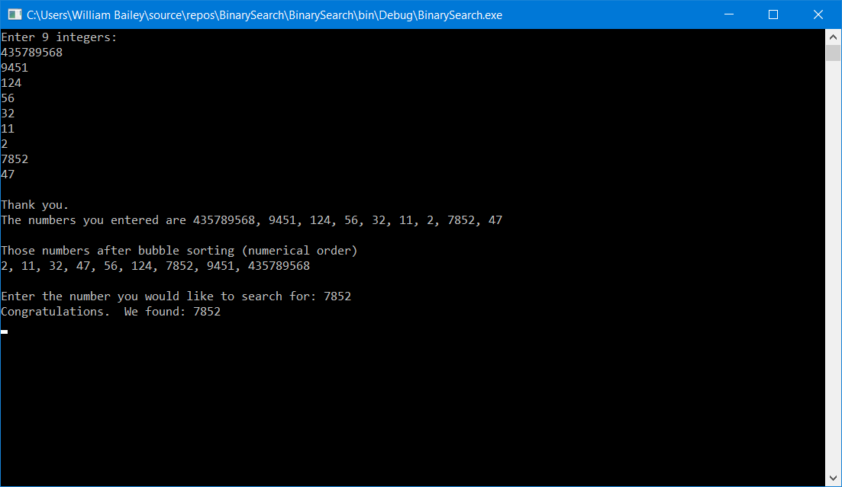

using System;

using System.Collections.Generic;

using System.Linq;

using System.Text;

using System.Threading.Tasks;

namespace BinarySearch

{

class SearchNum

{

static void Main(string[] args)

{

int[] Binary1 = new int[9];

int row = 0;

Console.WriteLine("Enter 9 integers: ");

for (row = 0; row < Binary1.GetLength(0); row++)

{

Binary1[row] = Convert.ToInt32(Console.ReadLine());

}

Console.WriteLine();

Console.Write("Thank you. \nThe numbers you entered are ");

for (row = 0; row < Binary1.GetLength(0) - 1; row++)

{

Console.Write(Binary1[row] + ", ");

if (row == 7)

{

Console.WriteLine(Binary1[row + 1]);

}

}

Console.WriteLine();

Console.WriteLine("Those numbers after bubble sorting (numerical order)");

for (int i = 0; i < Binary1.GetLength(0) - 1; i++)

{

for (int j = i + 1; j < Binary1.GetLength(0); j++)

if (Binary1[j] < Binary1[i])

{

int temp = Binary1[j];

Binary1[j] = Binary1[i];

Binary1[i] = temp;

}

}

for (row = 0; row < Binary1.GetLength(0) - 1; row++)

{

Console.Write(Binary1[row] + ", ");

if (row == 7)

{

Console.WriteLine(Binary1[row + 1]);

}

}

Console.WriteLine();

Console.Write("Enter the number you would like to search for: ");

int num = Convert.ToInt32(Console.ReadLine());

if (BinarySearch(Binary1, num) == true)

{

Console.WriteLine("Congratulations. We found: " + num);

}

else

{

Console.WriteLine("Number not found. Sorry..");

}

Console.ReadLine();

}

static bool BinarySearch(int[] a, int find)

{

bool found = false;

int low = 0;

int high = a.GetLength(0);

int mid = 0;

while (!found)

{

mid = (low + high) / 2;

if (find == a[mid])

{

return true;

}

else if (find < a[mid])

{

high = mid;

}

else

{

low = mid;

}

if (low >= high - 1)

{

return false;

}

}

return found;

}

}

}